Design and apply context-aware access controls based on user identity

List of Teammates

S.No. | Name | College Id | Phone No.
1 | SANDHIYA S | brubb | 9787727099
2 | SREEMATHI T | brubb | 9042512175
3 | DHARSANI C D | brubb | 7604933303
4 | VAISHNAVI A | brubb | 8056972173
5 | EPSHIBHA GUNASEELI A | brubb | 9025526435

COLLEGE NAME:
VET INSITUTE OF ARTS AND SCIENCE,ERODE.

Title of the Project: -
Design and apply context-aware access controls based on user identity

Overview: -
Designing and applying context-aware access controls based on user identity is a security approach that allows organizations to control access to systems, applications, and data by considering both the user’s identity and the context of the access request. Instead of relying only on traditional authentication methods like usernames and passwords, this approach evaluates additional factors such as the user’s role, device type, location, time of access, and risk level before granting permission. For example, a user may be allowed to access sensitive data only from a company-managed device and within the organization’s network during business hours. This method follows the principle of least privilege, ensuring users receive only the minimum access required to perform their tasks. Context-aware access control is a key component of modern security models like Zero Trust, as it continuously monitors user behavior and dynamically adjusts access permissions to reduce the risk of unauthorized access and protect critical resources.

Abstract: -
Context-aware access control based on user identity is an advanced security approach that enhances traditional access control mechanisms by incorporating contextual information during authentication and authorization processes. Instead of relying solely on static credentials, this method evaluates multiple factors such as user identity, device type, location, time of access, and behavioral patterns before granting access to systems or data. By applying policies based on these contextual attributes, organizations can ensure that only authorized users under appropriate conditions are allowed access to sensitive resources. This approach aligns with modern security frameworks like Zero Trust and helps reduce the risk of unauthorized access, data breaches, and insider threats. Implementing context-aware access control improves overall security posture while maintaining flexibility and usability for legitimate users.

Use Case Scenarios: -
Use Case Scenario 1: Secure Remote Employee Access
Employees often access organizational resources from remote locations. Context-aware access control ensures that access decisions are based on the user’s identity, device security, and location before granting permission to internal systems.
Output:
• User authentication: Employee identity verified through the organization’s Identity Provider (IdP).
• Location validation: Access allowed only from approved geographic locations or networks.
• Device compliance check: Access granted only if the device meets security policies.
• Role-based permissions: Employees can access only applications relevant to their job role.
• Activity monitoring: All user activities are logged for auditing and security analysis.

Use Case Scenario 2: Secure Access for Third-Party Vendors
External vendors may require temporary access to specific systems. Context-aware access control ensures that vendor access is restricted based on identity, role, and time-based policies.
Output:
• Vendor identity verification: Vendor authenticated through secure identity management systems.
• Limited application access: Vendors can access only the applications required for their project.
• Time-based access control: Access automatically expires after the contract or task completion.
• Behavior monitoring: Vendor activity is monitored for unusual or unauthorized actions.
• System isolation: Vendors cannot access unrelated systems such as internal databases or HR systems.

Use Case Scenario 3: Role-Based Access to Sensitive Applications
Critical applications such as HR systems, financial systems, and internal databases require strict access policies based on user identity and role.
Output:
• Identity-based authorization: Access granted based on department, job role, or responsibilities.
• Application-level protection: Each application has its own security policy.
• Unauthorized access prevention: Users without the required role cannot access or discover sensitive applications.
• Security logging: All access attempts are recorded for auditing purposes.
• Policy enforcement: Access policies are enforced regardless of user location.

Use Case Scenario 4: Secure BYOD (Bring Your Own Device) Access
Employees may use personal devices such as laptops or smartphones to access corporate resources. Context-aware access control evaluates device security and risk level before allowing access.
Output:
• Device verification: System checks whether the device meets security requirements.
• Conditional access: Access denied if the device is not secure or updated.
• Limited permissions: Personal devices can access only low-risk applications.
• Data protection: Prevents sensitive data from being downloaded to unsecured devices.
• Continuous monitoring: User activity monitored to detect suspicious behavior.

Use Case Scenario 5: Risk-Based Access Control During Security Incidents
If suspicious behavior or a potential security threat is detected, context-aware access control can dynamically adjust or revoke user access.
Output:
• Risk detection: System identifies unusual login attempts or abnormal behavior.
• Immediate access restriction: Access is limited or blocked automatically.

Stage – 1

Title of the Project: -
Integrate Zscaler with Identity Providers (IdPs) such as Azure AD, Okta, and Active Directory for seamless authentication and authorization.

List of Vulnerability Table: -

S.No. | Vulnerability Name | CWE/CVE - No
1. | Broken Access Control | CWE-22
2. | Security Misconfiguration | CWE-11
3. | Software Supply Chain Failures | CWE-447
4. | Cryptographic Failures | CWE-523
5. | Injection | CWE-91
6. | Insecure Design | CWE-419
7. | Authentication Failures | CWE-613
8. | Software or Data Integrity Failures | CWE-426
9. | Security Logging & Alerting Failures | CWE-117
10. | Mishandling of Exceptional Conditions | CWE-223

REPORT: -
- Vulnerability Name:Improper Limitation of a Pathname to a Restricted Directory ('Path Traversal').
- CWE/CVE: CWE-22
OWASP/SANS Category: A01:2025 Broken Access Control
Description: -
The product uses external input to construct a pathname that is intended to identify a file or directory that is located underneath a restricted parent directory, but the product does not properly neutralize special elements within the pathname that can cause the pathname to resolve to a location that is outside of the restricted directory.
Business Impact: -
The described vulnerability, known as Path Traversal, can have serious business impacts if exploited. Attackers may manipulate file paths to access sensitive files outside the restricted directory, leading to unauthorized access to confidential data such as system configurations, credentials, financial records, or customer information. This can result in data breaches, privacy violations, and possible system compromise, allowing attackers to gather information for further attacks. Such incidents can cause financial losses due to recovery costs, legal penalties, and operational downtime, while also damaging the organization’s reputation and customer trust.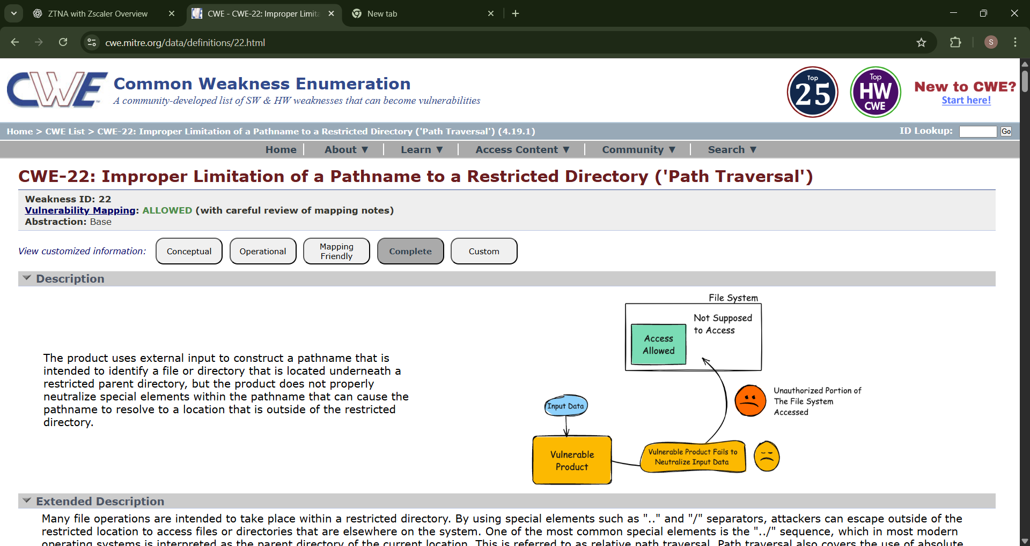
- Vulnerability Name: ASP.NET Misconfiguration: Creating Debug Binary
CWE/CVE: - CWE-11
OWASP/SANS Category: - A02:2025 Security Misconfiguration
Description: -
Debugging messages help attackers learn about the system and plan a form of attack.
Business Impact: -
If an ASP.NET application is misconfigured to create debug binaries, it can expose detailed debugging information about the system. This information may include file paths, server configuration details, application logic, and error messages, which attackers can use to understand how the system works and identify other vulnerabilities. As a result, attackers may be able to plan more effective attacks such as exploiting security weaknesses, accessing sensitive data, or compromising the server. This vulnerability can lead to data breaches, system compromise, service disruption, and loss of customer trust, ultimately causing financial loss and reputational damage to the organization.

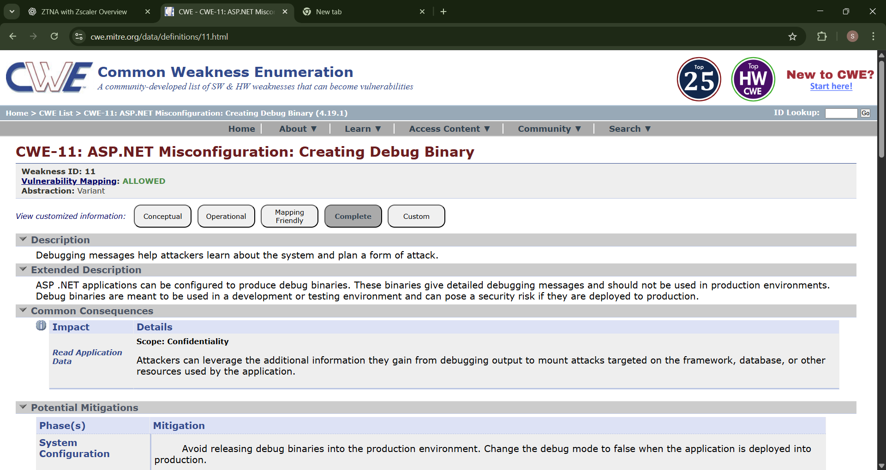

- Vulnerability Name: - Unimplemented or Unsupported Feature in UI
CWE/CVE: - CWE-447
OWASP/SANS Category: - A03:2025 Software Supply Chain Failures
Description: -
A UI function for a security feature appears to be supported and gives feedback to the user that suggests that it is supported, but the underlying functionality is not implemented.
Business Impact: -
If a UI security feature appears to be supported but is not actually implemented, it can create a false sense of security for both users and administrators. They may believe that a protection mechanism such as authentication, encryption, or access control is active when in reality it is not functioning. This can allow attackers to bypass security controls and gain unauthorized access to systems or sensitive data. As a result, the organization may face data breaches, security policy violations, and operational risks. Such weaknesses can also damage customer trust, regulatory compliance, and the organization’s reputation, potentially leading to financial losses and legal consequences.

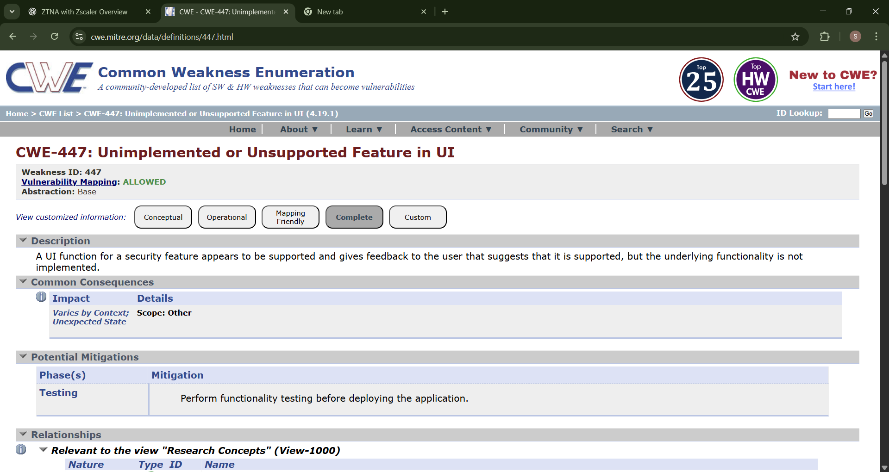

- Vulnerability Name: - Unprotected Transport of Credentials
CWE/CVE: - CWE-523
OWASP/SANS Category: - A04:2025 Cryptographic Failures
Description: -
Login pages do not use adequate measures to protect the user name and password while they are in transit from the client to the server.
Business Impact: -
If credentials such as usernames and passwords are transmitted without proper protection, attackers may intercept them through network attacks such as packet sniffing or man-in-the-middle attacks. This can allow unauthorized individuals to steal login credentials and gain access to user accounts or internal systems. As a result, sensitive information may be exposed, accounts may be misused, and attackers could perform unauthorized transactions or data manipulation. This vulnerability can lead to data breaches, loss of customer trust, financial damage, and possible legal or regulatory penalties for the organization due to failure to protect user authentication data.

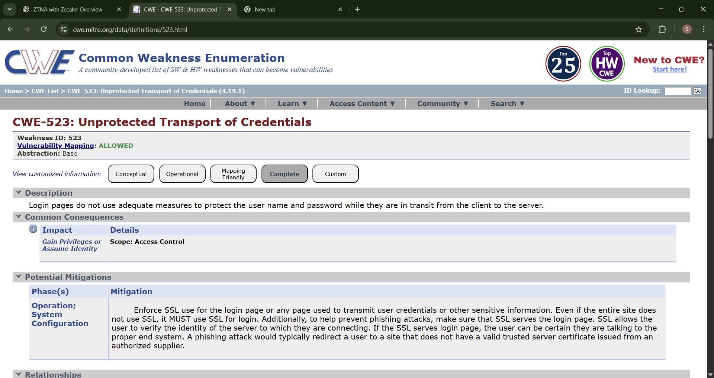

- Vulnerability Name: XML Injection (aka Blind XPath Injection)
CWE/CVE: - CWE-91
OWASP/SANS Category: - A05:2025 Injection
Description: -
The product does not properly neutralize special elements that are used in XML, allowing attackers to modify the syntax, content, or commands of the XML before it is processed by an end system.
Business Impact: -
If an application is vulnerable to XML Injection (Blind XPath Injection), attackers can manipulate XML queries by inserting malicious input into the XML data. This may allow them to bypass authentication, retrieve sensitive information, or modify application data without proper authorization. As a result, attackers could gain access to confidential records, alter system behavior, or disrupt normal application functions. This vulnerability can lead to data breaches, unauthorized system access, loss of data integrity, and service disruption, which may cause financial losses, regulatory issues, and damage to the organization’s reputation.

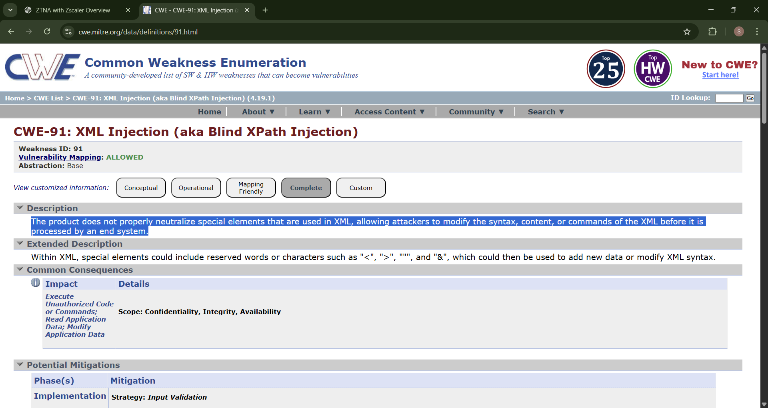

- Vulnerability Name: - Unprotected Primary Channel
CWE/CVE: - CWE-419
OWASP/SANS Category: - A06:2025 Insecure Design
Description: -
The product uses a primary channel for administration or restricted functionality, but it does not properly protect the channel.
Business Impact: -
If the primary channel used for administration or restricted functions is not properly protected, attackers may gain unauthorized access to critical system operations. They could intercept or manipulate administrative communications, allowing them to change system settings, access sensitive data, or control important services. This can lead to system compromise, data breaches, and disruption of business operations. Additionally, unauthorized administrative access may result in loss of data integrity, financial damage, regulatory violations, and serious harm to the organization’s reputation and customer trust.
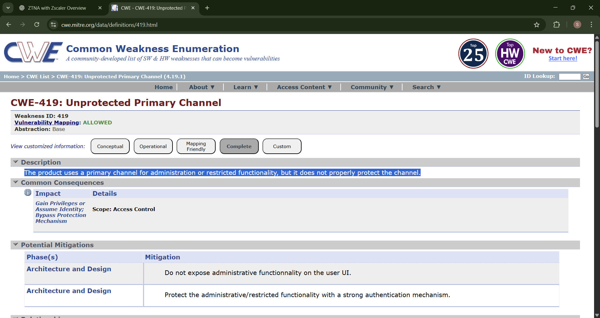

- Vulnerability Name: - Insufficient Session Expiration
CWE/CVE: - CWE-613
OWASP/SANS Category: - A07:2025 Authentication Failures
Description: -
According to WASC, "Insufficient Session Expiration is when a web site permits an attacker to reuse old session credentials or session IDs for authorization."
Business Impact: -
If a system has insufficient session expiration, attackers may be able to reuse old or stolen session IDs to gain unauthorized access to user accounts. Even after a user logs out or becomes inactive, the session may remain valid, allowing attackers to hijack the session and perform actions as the legitimate user. This can lead to unauthorized access to sensitive data, account misuse, and potential system compromise. As a result, organizations may face data breaches, financial loss, regulatory issues, and damage to customer trust and reputation.

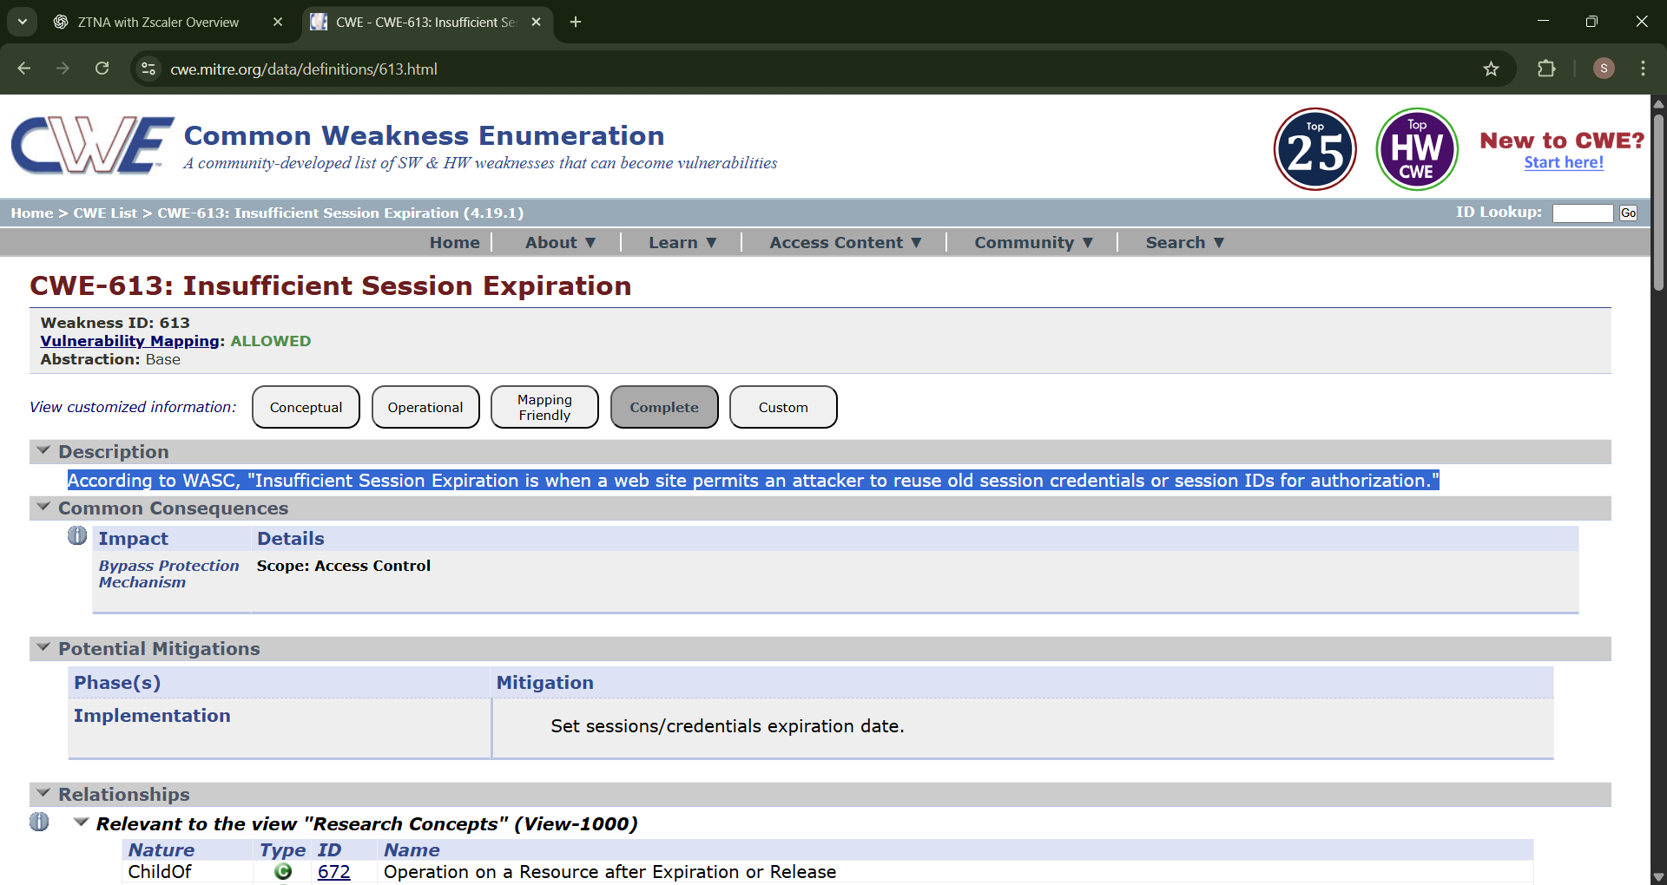

- Vulnerability Name: - Untrusted Search Path
CWE/CVE: - CWE-426
OWASP/SANS Category: - A08:2025 Software or Data Integrity Failures
Description: -
The product searches for critical resources using an externally-supplied search path that can point to resources that are not under the product's direct control.
Business Impact: -
If a system uses an untrusted search path to locate critical resources such as executables or libraries, attackers may place malicious files in locations that the application searches first. This can cause the system to execute unauthorized or malicious code instead of the legitimate resource. As a result, attackers may gain unauthorized control over the application or system, leading to data manipulation, system compromise, or service disruption. This vulnerability can result in data breaches, operational downtime, financial losses, and damage to the organization’s reputation and security integrity.
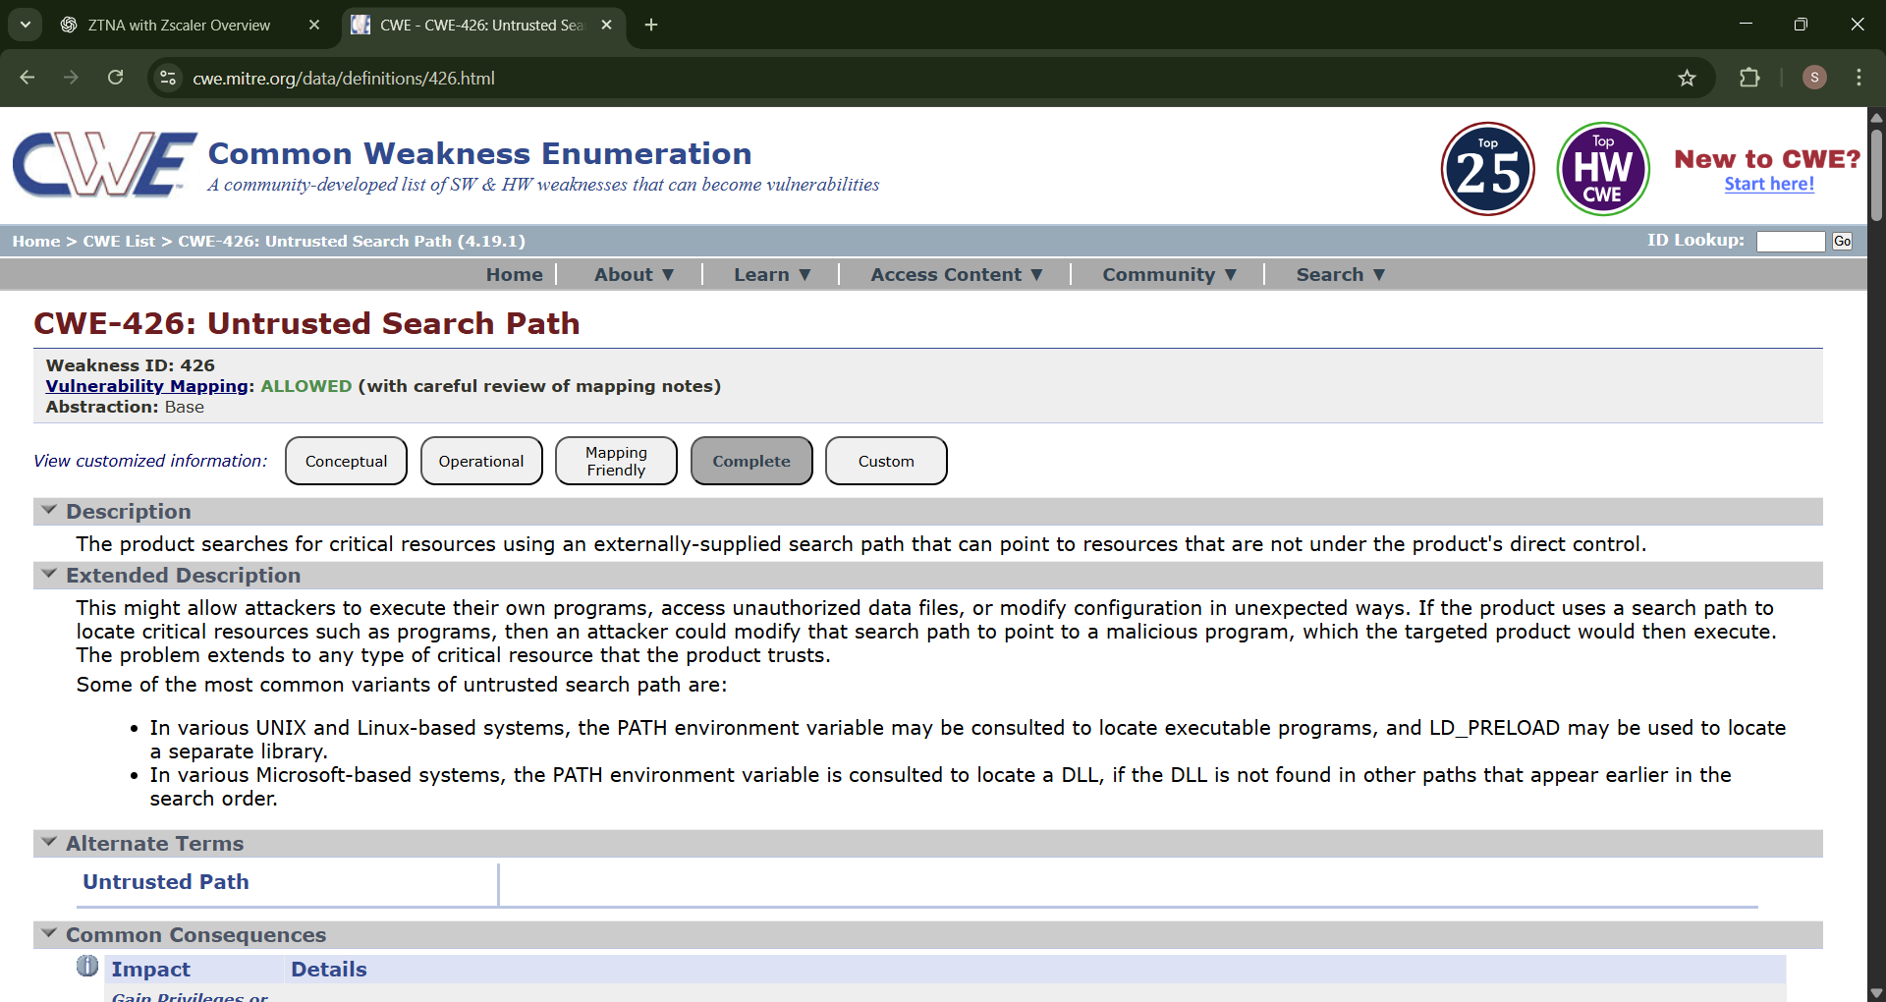

- Vulnerability Name: - Improper Output Neutralization for Logs
CWE/CVE: - CWE-117
OWASP/SANS Category: - A09:2025 Security Logging & Alerting Failures
Description: -
The product constructs a log message from external input, but it does not neutralize or incorrectly neutralizes special elements when the message is written to a log file.
Business Impact: -
If an application does not properly neutralize external input before writing it to log files, attackers may insert malicious or misleading data into the logs. This can allow them to manipulate log entries, hide their activities, or create false records, making it difficult for administrators to detect security incidents. As a result, important security events may go unnoticed, delaying incident response and investigation. This vulnerability can lead to undetected attacks, compromised system integrity, operational disruption, and potential financial and reputational damage to the organization.
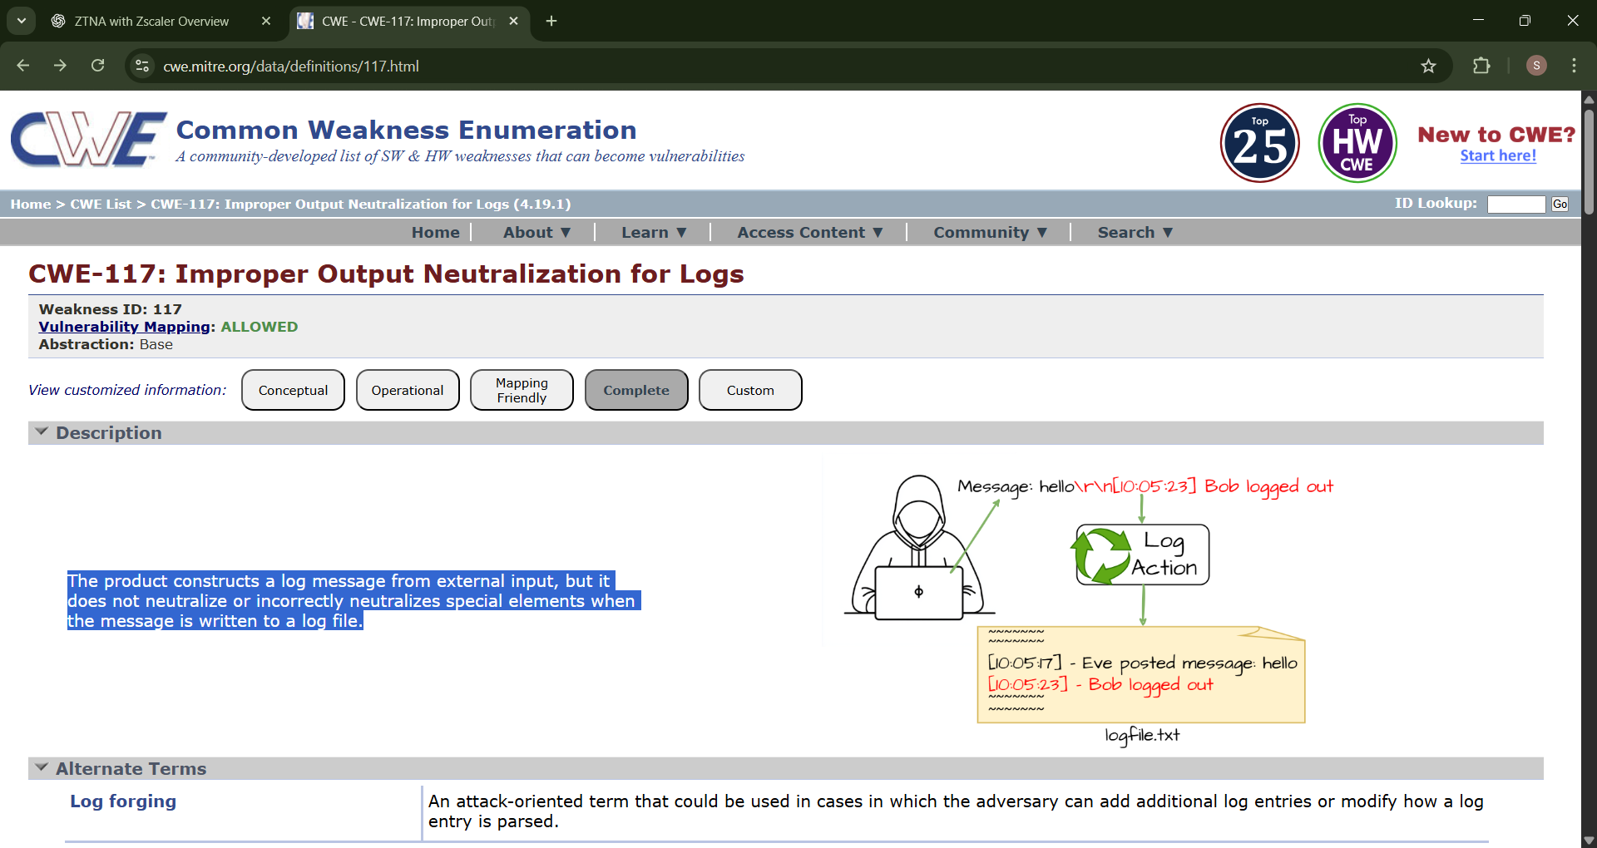

- Vulnerability Name: - Omission of Security-relevant Information
CWE/CVE: - CWE-223
OWASP/SANS Category: - A10:2025 Mishandling of Exceptional Conditions
Description: -
The product does not record or display information that would be important for identifying the source or nature of an attack, or determining if an action is safe..
Business Impact: -
If a system omits important security-related information during logging or error handling, it becomes difficult for administrators to identify, analyze, and respond to potential attacks or security incidents. Without proper records of suspicious activities, the organization may fail to detect unauthorized access, system misuse, or abnormal behavior in time. This can delay incident response and make forensic investigation more difficult. As a result, attackers may continue their activities unnoticed, leading to data breaches, system compromise, operational disruption, and potential financial and reputational damage to the organization.

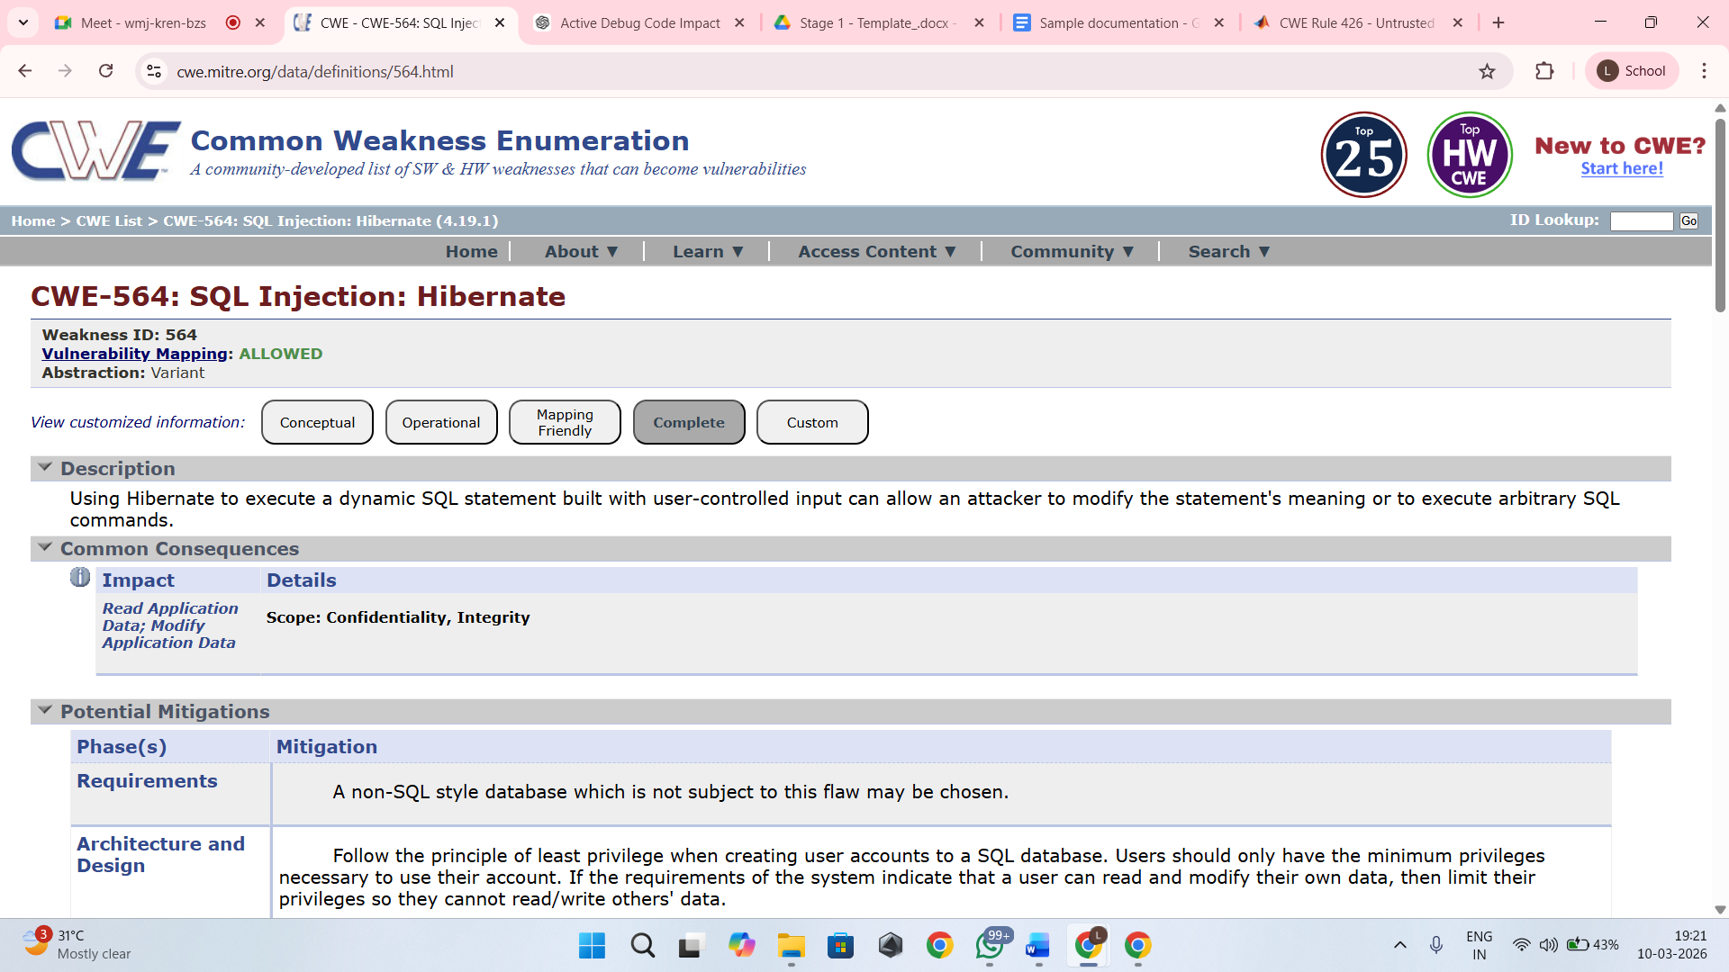

Stage 2

OVERVIEW :-

Nessus is a widely used vulnerability scanner that automates the detection of security weaknesses across networks, systems, and applications. From the screenshots you shared, I understand it as a comprehensive tool from Tenable that performed an informational scan on a remote web host, identifying configuration details like TLS support and missing headers rather than critical exploits.
Core Functionality
Nessus works by launching plugins—pre-built scripts that probe targets for known vulnerabilities, misconfigurations, and service details. In your scan (version 10.8.1), it ran checks in parallel on one host, fingerprinting the OS, detecting a Lua-based web service on a port, and noting informational items like supported TLS protocols (via plugin 10746) and additional DNS names (plugin 46180).​
It categorizes findings by severity: your results show low or info-level issues, such as HSTS missing (plugin 108098), which leaves HTTPS traffic vulnerable to interception, and TLS Next Protocol Negotiation enabled, advertising protocols like HTTP/2 that could signal outdated setups.
Key Features Observed
- Service Detection: Identifies web servers via banners or errors, as in your "NET Service Detection" output stating "A web is running on this port through Lua!" This helps map attack surfaces.​
- Protocol Checks: Enumerates TLS extensions (plugin 62564) and supported versions, flagging deprecated ones for remediation.​
- Fingerprinting: Gathers OS and host details without exploits, using methods like PCRE probes for high-confidence matches.​
- Compliance Auditing: Spots absences like HSTS headers or restricted methods disclosure, providing vendor fix guidance.​
Scan Workflow Insight
Your scan followed a standard flow: host discovery, port/service enum, vulnerability plugins, and reporting. Outputs include plugin IDs (e.g., 13524 for version leaks), risk factors (none high here), and remediation notes like adding Strict-Transport-Security headers. Reports export to formats like PDF/HTML for sharing security posture overviews.

Target website :- http://testphp.vulnweb.com/
Target ip address:- 44.228.249.3

List of vulnerability :-
s.no | Vulnerability name | Severity | plugins
1 | Host Fully Qualified Domain Name (FQDN) Resolution | Info | 12053
2 | Nessus SYN scanner | Info | Unknown
3 | TLS Next Protocol Negotiation | Info | 62564
4 | Additional DNS Names | Info | 46180.
5 | Nessus Scan Information | Info | 11936
6 | OS Fingerprinting | Info | 105558
7 | NET Service Detection | Info | Unknown
8 | TLS Protocols  Supported | Info | 10746
9 | HSTS Missing | Info | 108098
10 | Web Server Restricted Methods/Version | info | 13524

REPORT:-

Vulnerability Name:- Host Fully Qualified Domain Name (FQDN) Resolution
severity : - Info
Plugin:- 12053
Port :- 0
Description:-
This informational plugin identifies the Fully Qualified Domain Name (FQDN) of the scanned host by resolving its hostname through DNS or other network resolution methods. The scan determines how the host is recognized within the network and may reveal additional naming information about the system.
This finding does not represent a direct security vulnerability, but it provides information about the host's network identity which can be useful for asset identification and network mapping

solution:-
No remediation is required as this is an informational finding. However, organizations may:Ensure DNS records are properly configuredRestrict unnecessary DNS exposure if internal hostnames should not be publicly resolvable.Review DNS configurations to confirm that only required information is exposed.

Business Impact::-
There is no direct security impact. However, exposing internal hostnames or domain structure could assist attackers in network reconnaissance and mapping, which may help them plan further attacks against the infrastructure.

Vulnerability Name:-Nessus SYN scanner
severity : -info
Plugin:-unkown
Port :-0
Description:-
This plugin is a SYN 'half-open' port scanner. It shall be reasonably quick even against a firewalled target. Note that SYN scans are less intrusive than TCP (full connect) scans against broken services, but they might cause problems for less robust firewalls and also leave unclosed connections on the remote target, if the network is loaded.
solution:-
The Nessus SYN scanner is an information-gathering technique used during vulnerability assessment to identify open ports and running services on a target system. Since this is not a vulnerability but a scanning method, no direct remediation is required. However, organizations can reduce exposure by implementing proper network security controls. These include configuring firewalls and intrusion detection/prevention systems (IDS/IPS) to detect and block unauthorized port-scanning activities, restricting unnecessary open ports, and allowing access only to required services. Network administrators should also regularly review firewall rules, close unused ports, and implement network monitoring to detect suspicious scanning behavior from unknown sources. Proper logging and alerting mechanisms should be enabled so that security teams can quickly identify and respond to reconnaissance attempts.
Business Impact::-
Although the SYN scan itself does not represent a direct security vulnerability, it indicates that attackers or security tools may be performing reconnaissance on the network to discover open ports and active services. If sensitive services are exposed, attackers may use the gathered information to launch further attacks such as exploitation of vulnerabilities, brute-force attempts, or denial-of-service attacks. In addition, excessive scanning activity may affect poorly configured firewalls or network devices, potentially causing performance issues or leaving incomplete connections on the target system. Monitoring and controlling such activities helps organizations maintain better network security and prevent potential misuse of exposed services.

Vulnerability Name:- TLS Next Protocol Negotiation
severity : - info
Plugin:- 62564
Port :-8443
Description:-
This host supports TLS Next Protocol Negotiation. The remote host has the TLS Next Protocol Negotiation extension. This plugin enumerates the protocols supported by the remote service.
solution:-
TLS Next Protocol Negotiation (NPN) is a legacy TLS extension that allows a client and server to negotiate which application protocol will be used over a secure connection (for example, HTTP/1.1 or SPDY). This mechanism has largely been replaced by the more modern Application-Layer Protocol Negotiation (ALPN) extension, which is supported by newer versions of TLS. Since this finding is informational, it does not necessarily indicate a vulnerability. However, as a best security practice, organizations should review their TLS configuration and disable deprecated or unnecessary protocol negotiation mechanisms where possible. Administrators can update the web server or application server configuration to prioritize or exclusively use ALPN, upgrade TLS libraries to the latest supported versions, and ensure that only secure TLS protocols and cipher suites are enabled.
Business Impact::-
The presence of TLS Next Protocol Negotiation itself does not directly expose the system to immediate security risks. However, the use of outdated or legacy protocol negotiation methods may indicate that the server is running older TLS configurations or libraries. Over time, legacy features may become unsupported or may introduce compatibility and security concerns if they are not properly maintained. Attackers performing reconnaissance could use this information to understand the server’s TLS capabilities and identify potential weaknesses in the cryptographic configuration. Regularly reviewing and updating TLS settings helps organizations maintain strong encryption standards, improve compatibility with modern browsers, and ensure secure communication between clients and servers.

Vulnerability Name:- Additional DNS Names
severity : - info
Plugin:- 46180.
Port :-8443
Description:-
Additional hostnames were collected by Nessus. These are alternate names collected via misconfigurations. Versus generated a list of hostnames that point to different servers hosted on same virtual host. Solution: test with them using whole syntax
solution:-
The “Additional DNS Names” finding indicates that the scanning tool discovered multiple hostnames or alternate DNS records associated with the target server. These names may appear due to DNS configurations, virtual hosting setups, or shared hosting environments. Since this is an informational finding, it does not necessarily represent a direct vulnerability. However, administrators should review the discovered DNS names and verify whether they are legitimate and required for the organization’s infrastructure. Any unused, outdated, or misconfigured DNS records should be removed from the DNS server configuration. Security teams should also ensure that all identified hostnames are properly secured, configured with valid TLS certificates, and follow the same security policies as the primary domain. Additionally, penetration testing or validation can be performed on these alternate hostnames to ensure they do not expose unintended services or sensitive information.
Business Impact::-
The presence of additional DNS names may reveal information about the internal structure of the organization’s network or web infrastructure. Attackers can use this information for reconnaissance to identify hidden services, staging environments, or misconfigured systems that might not be intended for public access. If any of the discovered hostnames are improperly secured, they may provide an entry point for attackers to exploit vulnerabilities or gain unauthorized access. Regularly reviewing DNS configurations and ensuring proper security controls across all associated hostnames helps reduce the attack surface and protects the organization’s web infrastructure from potential threats.

Vulnerability Name:- Nessus Scan Information
severity : - info
Plugin:- 11936.
Port :-8443
Description:-
This plugin set holds information about the scan. The number of hosts (1). The Nessus version (10.8.1). The number of checks in parallel.
solution:-
The “Nessus Scan Information” finding provides general details about the vulnerability scan performed by the Nessus Vulnerability Scanner. It includes information such as the number of hosts scanned, the scanner version used, and the number of parallel checks executed during the scan. This plugin does not indicate a vulnerability but simply records metadata related to the scanning process. Therefore, no remediation action is required. However, organizations should ensure that vulnerability scans are conducted using updated scanning tools and configurations. Security teams should also maintain proper documentation of scan reports and review the results regularly to identify and address actual vulnerabilities detected during the assessment.
Business Impact::-
Since this finding only provides information about the scan itself, it does not pose any direct security risk to the system or network. The information is mainly useful for audit, reporting, and troubleshooting purposes. It helps security teams understand the scanning environment and verify that the assessment was conducted using a supported and up-to-date scanning tool. Properly documenting scan information also assists organizations in maintaining compliance records, tracking vulnerability management activities, and ensuring that security assessments are performed consistently across the infrastructure.

Vulnerability Name:- OS Fingerprinting
severity : -info
Plugin:- 105558
Port :-8448
Description:-
OS Fingerprints PCRE DoS was reported in plugin 10910. This is the highest confidence result reported in plugin 10910. The composite of fingerprints detected were reported in plugin 10910.
solution:-
The OS Fingerprinting finding indicates that the scanning tool was able to identify or estimate the operating system of the target host based on network responses and system behavior. This information is collected during the scanning process to help security teams understand the environment and identify potential vulnerabilities related to specific operating systems. Since this is an informational finding, it does not represent a direct vulnerability. However, organizations can reduce unnecessary exposure by limiting information disclosure through proper system hardening. This may include configuring firewalls to restrict unnecessary network responses, disabling unused services and ports, and ensuring that systems are updated with the latest security patches. Administrators should also implement intrusion detection and monitoring mechanisms to detect unauthorized scanning or reconnaissance attempts.
Business Impact::-
Although OS fingerprinting itself does not cause damage to the system, it may provide attackers with useful reconnaissance information about the underlying operating system and system configuration. If attackers can accurately determine the OS type and version, they may attempt to exploit known vulnerabilities specific to that platform. This can increase the risk of targeted attacks against the system. By reducing information exposure and maintaining secure system configurations, organizations can minimize the chances of attackers using reconnaissance data to plan further attacks.

Vulnerability Name:- NET Service Detection
severity : -info
Plugin:- Unknown
Port :-0
Description:-
Nessus is able to identify the service by banner or by looking at the error message it sends when it receives an HTTP request. Output: A web is running on this port through Lua!
solution:-
The “NET Service Detection” finding indicates that the vulnerability scanning tool was able to identify a network service running on the target system by analyzing the service banner or the response generated when an HTTP request was sent. In this case, the scan detected that a web service is running on the specified port and identified it through its response characteristics. This is an informational result and does not represent a direct vulnerability. However, administrators should review the detected services to ensure that only required services are running on the system. Unnecessary services should be disabled to reduce the attack surface. It is also recommended to limit banner information exposure, configure proper firewall rules, and ensure that the detected services are updated with the latest security patches.
Business Impact::-
Service detection results may reveal details about the services running on a server, including their type and sometimes their version. Attackers can use this information during reconnaissance to identify potential targets for exploitation. If outdated or vulnerable services are running, attackers may attempt to exploit known weaknesses associated with those services. Even though this finding is informational, exposing service information can increase the risk of targeted attacks. Regular monitoring, service hardening, and proper configuration management help organizations maintain a secure environment and reduce the likelihood of attackers using service identification information for malicious purposes.

Vulnerability Name:- TLS Protocols Supported
severity : -info
Plugin:- 10746
Port :-8448
Description:-
This script detects the protocols advertised by the remote service to be used in TLS connections. Note that failing to advertise other protocols does not mean the service does not support them.
solution:-
The “TLS Protocols Supported” finding indicates that the scanning tool identified which TLS (Transport Layer Security) protocol versions are supported by the remote service during secure communication. This check helps security teams understand the encryption protocols available on the server. Since this is an informational finding, it does not directly indicate a vulnerability. However, administrators should review the TLS configuration and ensure that only secure and modern protocols such as TLS 1.2 and TLS 1.3 are enabled. Older and insecure protocols like SSL 2.0, SSL 3.0, TLS 1.0, and TLS 1.1 should be disabled to prevent potential cryptographic attacks. Additionally, the server should be configured with strong cipher suites and updated TLS libraries to maintain secure encrypted communication.
Business Impact::-
If insecure or outdated TLS protocols are enabled on the server, attackers may exploit known weaknesses in those protocols to compromise secure communications. This could potentially allow attackers to intercept or decrypt sensitive data transmitted between the client and the server. Even though this finding is informational, it highlights the importance of reviewing and maintaining secure TLS configurations. Proper TLS configuration helps organizations protect sensitive information, maintain user trust, and comply with modern security standards and best practices for encrypted communication.

Vulnerability Name:- HSTS Missing
severity : -info
Plugin:- 108098
Port :-8443
Description:-
HTTP Strict Transport Security (HSTS) is an optional header that can be configured on the web server to instruct browsers to only communicate with the server over HTTPS. The lack of HSTS enables man-in-the-middle attacks.
solution:-
The “HSTS Missing” finding indicates that the web server does not include the HTTP Strict Transport Security (HSTS) header in its HTTPS responses. HSTS is a security feature that instructs web browsers to always connect to the server using HTTPS instead of HTTP. To address this issue, administrators should configure the web server to include the Strict-Transport-Security header in all HTTPS responses. A common configuration example is: Strict-Transport-Security: max-age=31536000; includeSubDomains. Before enabling HSTS, it is important to ensure that the website and all related resources are fully accessible over HTTPS and that HTTP requests are properly redirected to HTTPS. After configuration, the implementation should be tested to verify that the header is correctly applied across the web application.
Business Impact::-
If HSTS is not implemented, users may initially connect to the website through an unencrypted HTTP connection, which could be intercepted by attackers through man-in-the-middle attacks. This may allow attackers to manipulate or redirect traffic, potentially leading to data interception, session hijacking, or unauthorized access to sensitive information. Although this finding is informational, the absence of HSTS weakens the overall security of the web application. Implementing HSTS helps ensure that browsers always communicate securely with the server, thereby improving the protection of user data and maintaining trust in the organization’s online services.

Vulnerability Name:- Web Server Restricted Methods/Version Info
severity : -info
Plugin:- 13524
Port :-8443
Description:-
The web server running on the remote host appears to be hiding its version or name, which is a good thing. Using specially crafted requests, Nessus was able to gather the following information from the web server.
solution:-
The “Web Server Restricted Methods/Version Info” finding indicates that the web server is configured to hide its version or detailed server information from standard HTTP responses. This is generally considered a good security practice because it limits the amount of information exposed to external users. However, advanced scanning techniques can sometimes still retrieve certain details using specially crafted requests. To further improve security, administrators should ensure that unnecessary HTTP methods (such as TRACE, OPTIONS, PUT, or DELETE) are disabled if they are not required. Web server configurations should also be reviewed to confirm that server banners and version details are minimized or completely removed. Additionally, keeping the web server software updated with the latest security patches and implementing web application firewall (WAF) protection can further reduce the risk of information disclosure.
Business Impact::-
Although hiding server version information helps reduce information leakage, attackers may still attempt to gather details about the server through advanced probing techniques. If attackers successfully identify the server type or version, they may search for known vulnerabilities associated with that specific software and attempt targeted attacks. Even though this finding is informational, proper configuration and regular security updates are important to ensure that the web server remains protected against potential exploitation. Limiting exposed information helps reduce the attack surface and improves the overall security posture of the organization’s web infrastructure.keeping the web server software updated with the latest security patches and implementing web application firewall (WAF) protection can further reduce the risk of information disclosure.

Stage – 3
Report
Title of the Project: -
Design and apply context-aware access controls based on user identity

1. Centralized Identity Management
Centralized Identity Management is a key component in implementing Zero Trust Network Access (ZTNA) using Zscaler. In traditional network security models, access decisions are often based on the user’s network location, such as whether they are inside or outside the corporate network. However, in a Zero Trust model, access decisions are based primarily on verified user identity. Zscaler integrates with enterprise identity providers such as Active Directory, Azure Active Directory, Okta, and other Identity and Access Management (IAM) systems to create a centralized identity management framework.
Through centralized identity management, organizations can maintain a single source of truth for user identities, roles, and permissions. All user authentication and authorization processes are handled through the centralized identity system, ensuring consistency across different applications and services. This simplifies administrative tasks, as IT teams no longer need to manage multiple user accounts or access policies across different systems. Instead, identity information is synchronized and managed in one location.
Another major benefit is improved security. Since ZTNA relies on identity-based access rather than network access, every request to access an application is verified based on the user’s identity, device posture, and security policies. This ensures that only authenticated and authorized users can access specific resources. Centralized identity management also allows organizations to quickly update access privileges when employees change roles or leave the organization. By implementing centralized identity management within Zscaler ZTNA, organizations can achieve stronger security, simplified administration, and more efficient access control.

2. Single Sign-On (SSO) Authentication
Single Sign-On (SSO) authentication plays an important role in improving both security and user experience in a ZTNA environment. SSO allows users to authenticate once and gain access to multiple applications without repeatedly entering their credentials. When integrated with Zscaler ZTNA, SSO provides a seamless and secure method for accessing enterprise applications while maintaining strong authentication controls.
In a traditional environment, users often have to remember and manage multiple usernames and passwords for different applications. This can lead to password fatigue, where users reuse weak passwords or write them down, increasing security risks. SSO eliminates this problem by allowing users to log in once through a trusted identity provider and gain access to authorized applications. Once authenticated, Zscaler verifies the user’s identity and grants access according to predefined security policies.
From a security perspective, SSO reduces the number of authentication points and centralizes authentication processes. Administrators can enforce strong authentication policies through the identity provider, such as password complexity rules or multi-factor authentication. If a user’s account needs to be disabled or modified, administrators can update the identity provider, and the changes automatically apply to all connected applications. This simplifies identity management while maintaining high security standards.
Overall, SSO improves productivity by allowing users to quickly access the resources they need while ensuring that access remains secure and centrally controlled.

3. Enhanced Security and Access Control
One of the primary objectives of implementing ZTNA using Zscaler is to enhance security and strengthen access control mechanisms. Traditional network security approaches typically grant users access to an entire internal network once they successfully authenticate through a VPN. This model increases the risk of lateral movement within the network if an attacker compromises a user account. ZTNA eliminates this risk by providing application-level access rather than network-level access.
With Zscaler ZTNA, users are granted access only to specific applications they are authorized to use. This approach follows the principle of least privilege, which ensures that users receive only the minimum level of access necessary to perform their tasks. Access decisions are based on multiple factors, including user identity, device health, location, and security policies defined by administrators.
Additionally, Zscaler continuously evaluates access requests in real time. If any suspicious activity or security risk is detected, the system can automatically block or restrict access. This dynamic access control mechanism significantly reduces the attack surface and prevents unauthorized access to sensitive resources.
By restricting access to individual applications and continuously verifying security conditions, organizations can protect critical systems from cyber threats such as credential theft, insider attacks, and unauthorized access. This approach provides a stronger and more flexible security framework compared to traditional network security models.

4. Automated User Provisioning and Deprovisioning
Automated user provisioning and deprovisioning are essential features for efficiently managing user access in modern organizations. In a ZTNA environment implemented with Zscaler, automation ensures that users receive the appropriate level of access based on their roles within the organization. This process is typically integrated with identity management systems and directory services.
User provisioning refers to the process of granting access to applications and resources when a new employee joins the organization or when an existing employee requires additional access. Instead of manually configuring access for each user, administrators can define role-based policies that automatically assign permissions based on job roles or departments. This reduces administrative workload and ensures consistent access control policies across the organization.
Deprovisioning is equally important for maintaining security. When an employee leaves the organization or changes roles, their access to certain applications must be immediately revoked or modified. Automated deprovisioning ensures that these changes occur instantly through the identity management system. This prevents former employees or unauthorized users from retaining access to sensitive systems and data.
Automation also reduces the risk of human error, which is a common cause of security vulnerabilities in manual access management processes. By implementing automated provisioning and deprovisioning within Zscaler ZTNA, organizations can maintain accurate access controls while improving operational efficiency and security.

5. Multi-Factor Authentication (MFA) Support
Multi-Factor Authentication (MFA) is a critical security feature that strengthens the authentication process by requiring users to provide multiple forms of verification. In addition to entering a password, users must confirm their identity using an additional factor such as a mobile authentication app, a one-time password, biometric verification, or a hardware security token.
When Zscaler ZTNA is integrated with identity providers that support MFA, organizations can significantly enhance their security posture. Even if an attacker obtains a user’s password through phishing or other attacks, they would still need the additional authentication factor to gain access. This greatly reduces the likelihood of unauthorized access to enterprise applications.
MFA is particularly important in modern work environments where employees access corporate applications from various locations and devices. By requiring multiple forms of authentication, organizations can ensure that only legitimate users can access sensitive resources. Administrators can also configure MFA policies based on risk factors, such as requiring additional verification when users attempt to access applications from unfamiliar devices or locations.
Overall, MFA adds an essential layer of security to ZTNA deployments and helps organizations protect their systems from credential-based attacks.

6. Improved Monitoring, Logging, and Compliance
Effective monitoring and logging are essential for maintaining visibility into user activities and ensuring that security policies are being properly enforced. Zscaler ZTNA provides detailed monitoring and logging capabilities that allow administrators to track user access to applications in real time. These logs include information such as user identity, device details, access location, and the specific applications accessed.
This visibility enables security teams to detect suspicious behavior and respond quickly to potential security threats. For example, if a user attempts to access an application from an unusual location or device, administrators can investigate the activity and take appropriate action. Continuous monitoring also helps organizations identify potential vulnerabilities and improve their overall security posture.
In addition to improving security, logging and monitoring support regulatory compliance requirements. Many organizations must comply with industry regulations and standards that require detailed records of user access and security events. Zscaler’s reporting and logging capabilities provide the necessary documentation to demonstrate compliance with these requirements.
By providing comprehensive monitoring, logging, and reporting features, Zscaler ZTNA helps organizations maintain strong security governance, quickly detect threats, and ensure compliance with regulatory standards.

